LVCAM: Decorating AF with Interfaces
Github repo: https://github.com/natev51/LabVIEW-Composed-Actor-Model-LVCAM
developed by Nathan Davis, Experimental Physics Ph.D. Student
Suggestions welcome! Contact:
davisnat@pdx.edu
NI Profile: https://forums.ni.com/t5/user/viewprofilepage/user-id/738042
Discord: Nathaaan#7660
Join the AF Guild Discord: https://discord.gg/aJqdbHKG (Find me as NathanDavis)

If you’d like a more recent copy of the documentation, please contact me so I can push it to Git :)

If you’re not familiar, I recommend taking a look at the Decorator Pattern, State Pattern, Strategy Pattern videos on Youtube.
Also, check the Gang of Four book and Dive into Design Patterns
They’re critical for understanding the following framework:
Strategy for the Msgs
Decorator for extending functionality of the Self Actor to the Dev Actor
State for the Msging and Destroying States of the Self Actor

Contact me personally and I will give you videos I would recommend.. I only learned about Design Patterns a couple months ago.. I’m still learning!
As will be apparent, I’m still a beginner, learning the basics. I’d like to hear your feedback :) Thank you!

1. LabVIEW Composed Actor Model (LVCAM)
The inspiration of this work is directly correlated to the Actor Framework (AF) developed by Stephen Loftus-Mercer and Allen C. Smith. Since its release in 2010, there have been many hundreds of other individuals who have contributed to the success of the AF. I have been using the AF for over a year and recently having learned about the SOLID Design Principles, I have attempted to create a SOLID focused design that uses concepts presented in the AF. It should be noted that Dmitry Sagatelyan through his recorded presentations and forum posts had introduced me to the SOLID Design Principles. He has his own proprietary SOLID actor design. This is my attempt at creating a Composition based Actor Model in LabVIEW using SOLID principles. This, instead of a class inheritance based OOP framework, uses an interface composition based Decorator Pattern framework to achieve similar goals. The video that made things click is linked and highly recommended for anybody using OOP: Only Use Inheritance If You Want Both of These.
LVCAM follows the philosophy of the Actor Model stated in the Wikipedia
- “Objects with locks (e.g., as in Java and C#) can be modeled as a serializer, provided that their implementations are such that messages can continually arrive (perhaps by being stored in an internal queue). A serializer is an important kind of actor defined by the property that it is continually available to the arrival of new messages; every message sent to a serializer is guaranteed to arrive.” - Actor model
and has been created following the concepts of the Actor Framework (AF) queue (Q) based message (Msg) system. The tree-like hierarchy of messaging is enforced (see the Observer Pattern later on for advanced Msging). Of the differences between LVCAM and AF, the following are of importance:
- Priority Msgs only exist to push a Msg to the front of the Msg Q DVR.
- Dev Actor does not inherit from Actor Class, rather composing in the Actor Interface.
- Full encapsulation of Msg Q DVRs. Msg Q DVRs can never be accessed by the Dev Actor. This upholds the tree-like hierarchy of messaging by restricting the Dev Actor from sharing Msg Q DVRs within a Msg.
- No community scoping. This is to encourage PPL builds.
- An actor can ONLY exist with a Call Actor, promoting Orderly Destruction of actors.
- Factory Pattern promoted in creating an actor, being able to use it’s own private data (keeping the contents private to the actor (via the Actor Setup method).
- Msgs are already in the form of interface libraries, promoting how to create a Msg (scripting not complete, yet)
- The front panel for an actor is not limited to the Msging loop. Rather, front panels are event driven async methods, promoting the swapping capability of front panels without needing to affect the Msging loop OR unbundling the actors private data by substituting the actor.
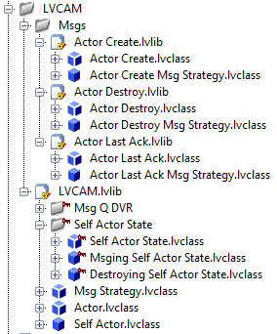

2. Dev Actor
Dev Actor is the actor which the developer is developing. This is the class which is decorating the Self Actor via the Actor interface. The Dev Actor is the placeholder for the name for the actor being developed. Replacements such as Logger, Pressure Gauge, XY Stage, etc. This class also implements methods, tied to Msgs which can be received. The Dev Actor must both:
- inherit from the Actor interface and
- compose in the Actor interface.
Upon instantiation of the Dev Actor, the Self Actor is bundled into the Actor interface (which is composed in the Dev Actor). This is the Decorator Pattern where the Dev Actor will decorate the functionality of the Self Actor methods. The methods that are decorated are:
- Actor Create
- Actor Destroy
- Actor Last Ack
- Actor Setup
- Actor Receive
- Actor Teardown
All of these methods (except currently Actor Setup) have implementations in Self Actor, which are overridden in Dev Actor so that the Developer can optionally extend functionality.
When referring to the Self Actor, it is implied that the Self Actor is composed (via the Actor interface) in the Dev Actor. When referring to any of the overridden methods in the Self Actor, it is implied that the Dev Actor is decorating the Self Actor methods.

2.1. Naming Conventions
LVCAM uses terminology relative to the Self Actor. Effectively, the Dev Actor composes in the Self Actor, so one can think of the Dev Actor as the Self Actor.. yes, confusing already. All Msgs that the Dev Actor receives are executed with terminology in terms of itself. For example, when the Last Ack Msg is received, the inputs are Nest Actor because relative to the Dev Actor (Self Actor), these inputs come from the Nest Actor.
The Dev Actor can send ANY Msg to any Actor. Whether the Msg can be received in the recipient Actor is determined from a type casting in the Msg method for that Msg.
Relative to the Dev Actor (Self Actor) Msgs can be sent via the polymorphic Msg Send.vi to the
- Call Actor (the Call Actor is guaranteed to exist)
- Self Actor
- Nest Actors (whose Msg Q DVRs have been created)
The linked forum posts show the confusion with naming convention of Qs (not duplicate links):
Re: Request: lose the "Caller-To-Actor" and "Actor-To-Caller" language
Re: Request: lose the "Caller-To-Actor" and "Actor-To-Caller" language

The Self Actor implicitly knows about other Actors because of their Self Msg Q DVRs. Relative to the Self Actor, these other Self Msg Q DVRs are the:
- Call Msg Q DVR (1)
- Self Msg Q DVR (1)
- Nest Msg Q DVRs (N = 0,1,2,..)

2.1.1. Create and Destroy
The “Created” and “Destroyed” naming convention is used here, as suggested by a post by Daklu:
Re: Request: lose the "Caller-To-Actor" and "Actor-To-Caller" language
Further, replacing Stop with Destroy:
- Re: Request: lose the "Caller-To-Actor" and "Actor-To-Caller" language
- Re: Request: lose the "Caller-To-Actor" and "Actor-To-Caller" language

2.2. Actors and Msgs
The Dev Actor can receive only pre determined messages, as determined by the interface methods the Dev Actor inherits. For example, there are three Actor Msgs that must be overridden:
- Actor Create
- Actor Destroy
- Actor Last Ack (it is discouraged to send this Msg in the Dev Actor, this only occurs in the Self Actor)
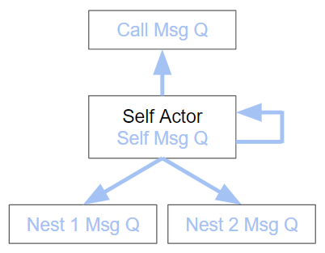
Therefore, because the Dev Actor composes in the Self Actor (via the Actor interface), the Msg Q DVRs are not known by the Dev Actor. This fully encapsulates the DVRs, not allowing the developer to have access to them. This keeps the terminology very Actor and Msg oriented, emphasizing Actor-Actor communication via Msgs. Therefore, the developer will never know about the Msg transport: the Msg Q DVRs. Therefore, nowhere in the Dev Actor will there be ANY terminology related to the Msg Q DVRs.

2.3. Actor Model
The General Actor Model takes an Actor and allows the Actor to send Msgs to other Actors (this includes itself):
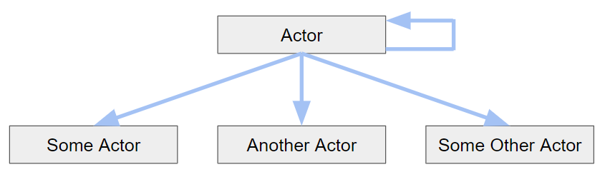
Of the Actors that Actor can know about, LVCAM constrains the Actor to know about
- 1 Call Actor,
- 1 Self Actor, and
- N Nest Actors
with the picture before replaced with this terminology:
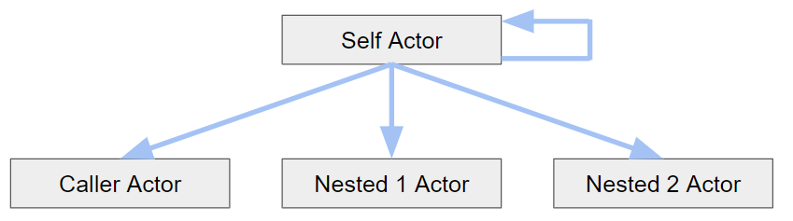
Rearranging shows the tree-like hierarchy of messaging:
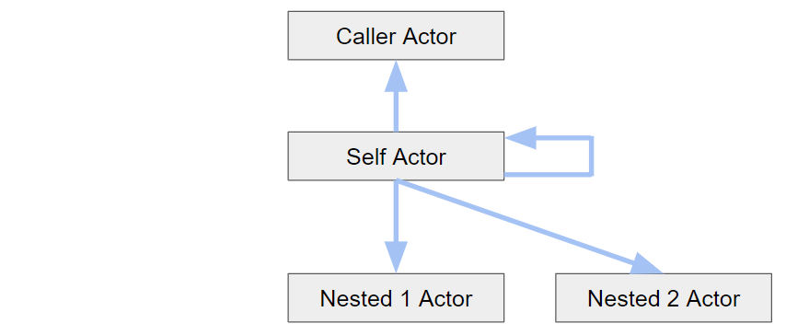

3. Msgs

3.1. Msg Strategy.lvclass
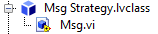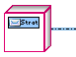
Msg.vi replaces Do.vi.
Msg Strategy.lvclass is a Strategy Pattern because each subtype (concrete xxxx Msg.lvclass) is behaviorally different, executing the Msgs respective method:
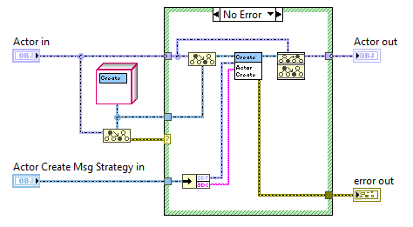
The extension at the end “xxxx Msg Strategy.lvclass” should be reserved for Msgs. This adheres to common naming conventions for interfaces and subtypes. For example the interface Msg Strategy.lvclass has subtypes:
- Actor Create Msg Strategy.lvclass and
- Actor Destroy Msg Strategy.lvclass
Msgs are strictly dynamic dispatch output or no output at all. This is to preserve the Dev Actor, specifically the Self Actor, from being mutated by a SD output terminal because any memory leaks of the Msg Q DVRs will cause unpredictable behavior.

3.2. Interface Msg Library
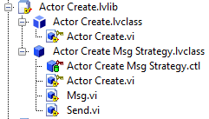
The LVCAM has three dedicated Msgs:
- Actor Create Msg Strategy.lvclass
- Actor Destroy Msg Strategy.lvclass
- Actor Last Ack Msg Strategy.lvclass
These all follow the template for a Msg library.
All methods tied to a Msg must be abstracted into an interface. Therefore, every Msgs and their libraries take the form:
xxxxx.lvlib
+xxxxx.lvclass (interface)
#xxxxx.vi
#type def.ctl***
+xxxxx Msg Strategy.lvclass
#xxxxx.vi
+Msg.vi
+Send.vi
***When a method tied to a Msg has an input of a typedef: The type def should be put in the interface and marked as protected. This ensures that if another class wants to use this type def, they must inherit from the interface.

3.2.1. Msgs Private to an Actor.
Old Way:
Why would you use an interface at this point if an actor needs to send itself a message, and only that actor is going to receive it, I make it part of the library and mark it private to that library
New Way:
This follows the actor philosophy in that a message is sent away (abstractly), it just so happens that a message is returned to itself.

A Msg cannot be in an actor's library.
Declaring all messages must be tied to an interface
I like the extreme statement of All Messages are tied to an Interface
Even though as developers of the actor, we know that the message is to be returned to itself, the actor only knows that it is sending a Msg, that’s it. It is not the actors responsibility to know where the address of the Msg is.. just that the message is sent. So from the Msg point of view, it's still abstract in that it is being sent out somewhere.

4. Self Actor State
The Self Actor uses the State Pattern for it’s two states:
- Msging
- Destroying
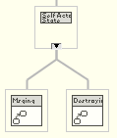
The naming convention is standard for interface and subtype naming. For example, the interface Self Actor State.lvclass has two subtypes:
- Msging Self Actor State.lvclass and
- Destroying Self Actor State.lvclass
This interface and these classes are marked private because only the Self Actor Class will use them. They could be marked as friends via the community scope so that only Self Actor could use them, but marking them as private is fine. Since community scope does not work well with PPLs.
In the interface, there exists a State Change method which transitions states and three DD methods (abstract) with different implementations held in the two states. There are ALL Core methods used directly in their respective methods in Self Actor:
- Actor Destroy Core
- Actor Receive Core
- Actor Teardown Core
For example, Actor Teardown Core is used in Actor Teardown.
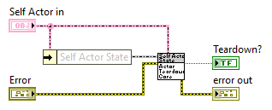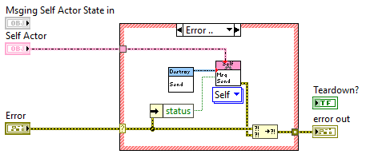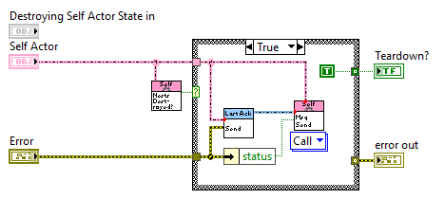
More states can easily be added in the future by adding another concrete class such as “Error Self Actor State” which specifically handles errors.

5. Actor.lvclass
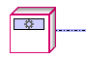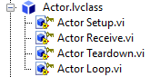
This is the interface that both the Self Actor and the Dev Actor inherit from. It contains three DD methods (abstract) that the Self Actor and Dev Actor must implement and the Actor Loop which is a SD method used as the main loop for Msgs.
The Actor xxxx.vi signature is displayed before all of the overridden methods because these are decorator methods that will be overridden in the Dev Actor. In the overridden Dev Actor, the developer can quickly glance and to tell which methods are strictly used for decorating the Self Actor. This goes for the Msgs as well. They're just tied to interfaces that Actor inherits from:
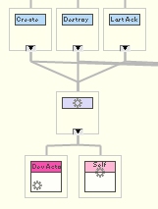

5.1. Actor Loop.vi
Actor Loop is used in Actor Create.vi. This is the Async Call.
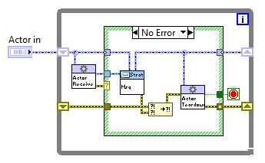
Here, all of the methods are the Actor interface derived methods. This is because at run time, the object on the wire is not known until runtime and this allows the Decorator Pattern to be used, wrapping the method functionality in Self Actor methods with the Dev Actor functionality. It is this Dev Actor object that will be on this Actor wire.
This method should never be called in Dev Actor. It is only called in the Actor Create.vi.

6. Self Actor.lvclass
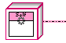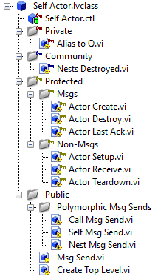

6.1. Msg Q DVR methods
These are a collection of vis that manipulate the Msg Q DVRs.
This is a highly performant use of sending messages not only over a Q, but with a DVR, accessing memory directly.
Alias:string is strictly for providing an alias for the Msg Q DVR. The Alias:string should be unique.
All Msg Q DVRs are identified by the Alias they’re assigned in the Obtain Msg Q DVR.
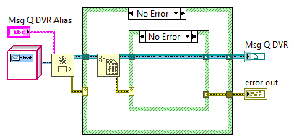
Depending on the priority, Msgs are EnQd either:
- At the back of the Msg Q DVR
- To the front of the Msg Q DVR (should be used sparingly)
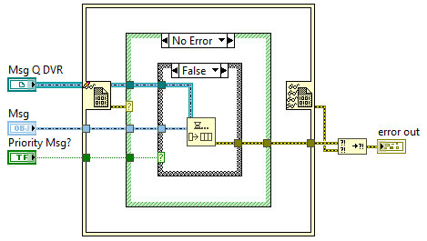
These methods are private because they will never be used outside of the Self Actor. It is this intention to abstract away the Msg Q DVRs from the developer.

6.2. Alias to Q.vi
This returns the Nest Msg Q DVR for the respective Msg Q DVR Alias.

6.3. Nests Destroyed
Used in the State Pattern to confirm if the Nest Actors have been destroyed.

6.4. Actor Create.vi
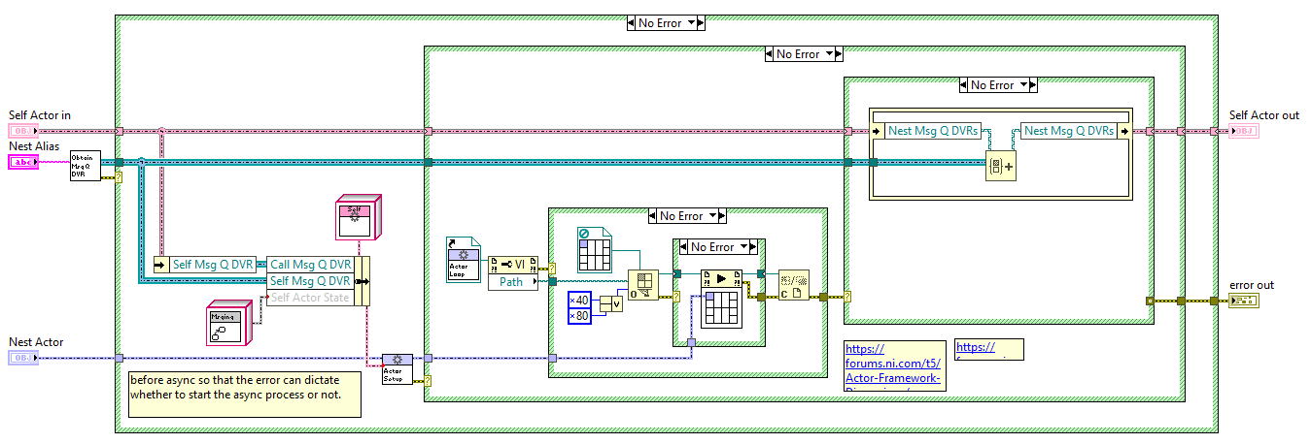
This method creates a Msg Q DVR for the Nest Actor, placing this Msg Q DVR in its private data and the Nest Actor private data. Since this Actor creates the Msg Q DVR, it is also its responsibility to release the Msg Q DVR. Releasing the Msg Q DVR occurs here on an error and more often from the Actor Last Ack Msg that the Nest Actor sends after it has been destroyed. Therefore, every actor ALWAYS has a Call Actor. There can exist NO orphan actors.

6.4.1. Creating Nest Actors
Take the following tree-like hierarchy of messaging in our application instance:
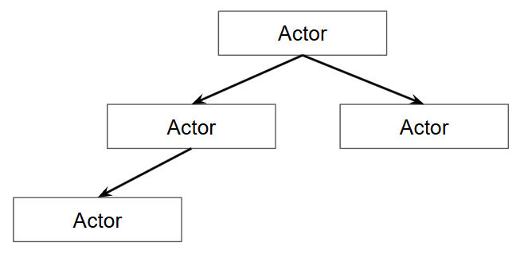
When creating more Nest Actors, the tree is further developed:
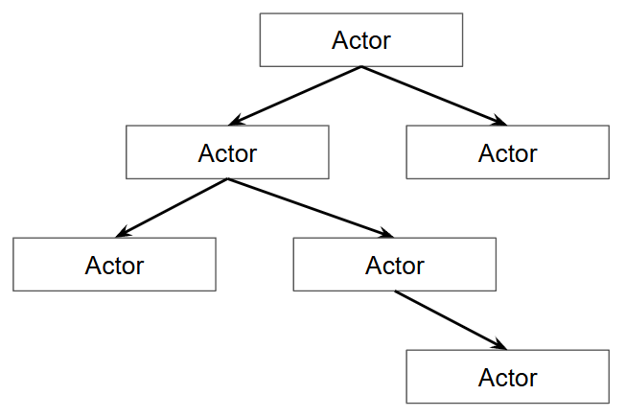
When a different executable or application creates an Actor that is coupled to the already present hierarchy (such as when a remote server calls this application to run (cRIO)), a new messaging hierarchy (red) IS NOT created:
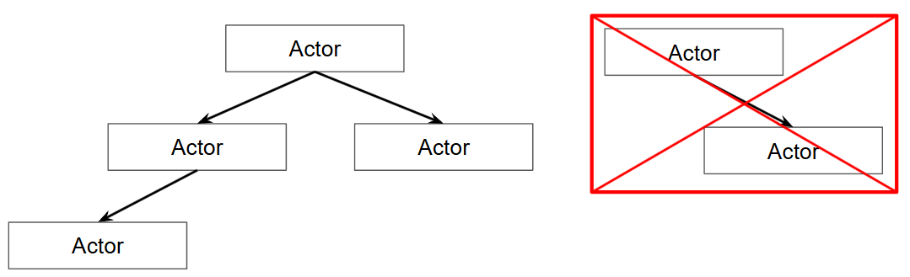
These are Nest Actors, with their creation by a different executable or application. Rather, this is an extension to the already created messaging hierarchy. This green box shows the developer that these Nest Actors extend the tree-like hierarchy of messaging, albeit from a different executable or application instance:
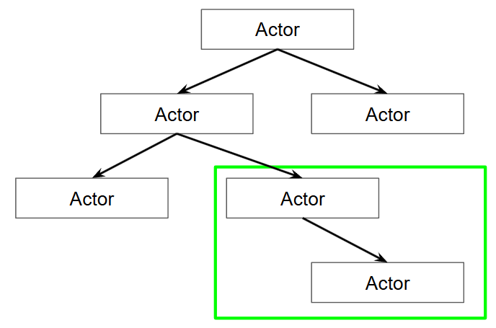

6.4.2. Saving Nest Msg Q DVRs
The Nest Msg Q DVR is saved in the private data of Self Actor. This is to hold onto the Msg Q DVR, releasing the Msg Q DVR ONLY in the Actor Last Ack method.
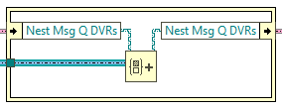

6.4.3. Dev Actor Override
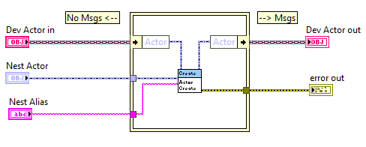
Disclaimer: Msgs CANNOT be sent to the Nest Actor before the Self Actor method call. This is because the Msg Q DVR has not been set up yet. Rather, Msgs must come after the Self Actor method call (and should only occur if the error output is a no error case).
It is discouraged to create another Nest Actor while the first Nest Actor is also being created. This means that the Actor Create method should not be used before the Sefl Actor method.

6.5. Actor Setup.vi
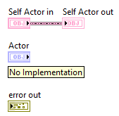
This is the decorator method in the Decorator Pattern. This is the Self Actor decorator.
After Actor Setup, the Actor Loop is started. Since the Self Actor has been bundled into the private data, the developer can send Msgs here. Msgs after the bundling of the Actor.

6.5.1. Dev Actor Override
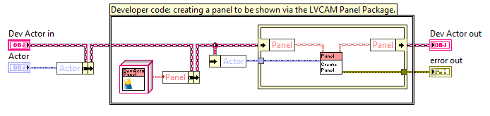
This is where any setup to the Nest Actor should occur. This is useful because the setup happens within the Nest Actor itself, i.e. there can be bundling and unbundling of data (here the Panel object) for this actor including reference setup, method execution, object creation via the factory pattern.
Note that the Self Actor Actor Setup is not called here since it has no implementation and would do nothing.
Any setup for the Dev Actor that deals with the Actor creating the Dev Actor is done in the Actor Create.vi.

6.6. Actor Receive.vi
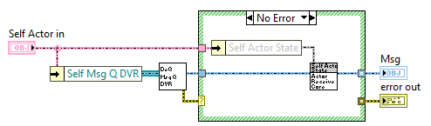
Msgs are DeQd here.
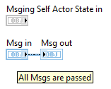
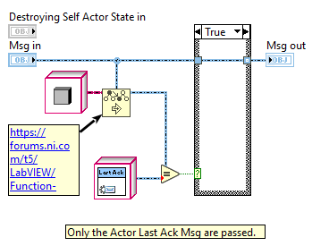

6.6.1. Dev Actor Override
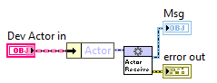

6.7. Actor Teardown.vi
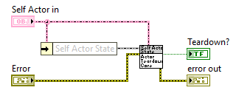
Though this method can be overridden for extended functionality in the Dev Actor, this method should never be used elsewhere in the Dev Actor. This method always executes after a Msg has executed, evaluating the error that comes from the Msg. All errors will go through Actor Teardown. This addresses the statements found here: Re: AF error reporting and handling. Also of interest: Re: Actor Stopping/Error Handling
Error codes do not destroy an actor. Only when the Teardown? output boolean is true will the Actor be destroyed. The two conditions must be fulfilled:
- Self Actor in the Destroying State and
- all Nest Actors are destroyed.
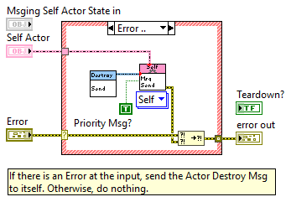
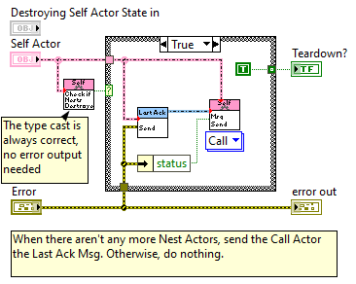

6.7.1. Dev Actor Override
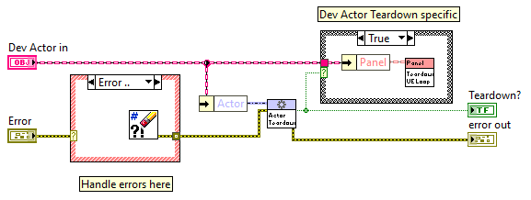
This is where any errors can be handled and is to be done before the Self Actor method call.
Since all errors will go through Actor Teardown, one can always log errors from here in their Dev Actor override without needing to worry about any errors that might have gone missing. Further, there could be another composed class to Dev Actor that does the error logging. This functionality will decorate the already applied Self Actor functionality in the Dev Actor override.

6.8. Actor Destroy.vi
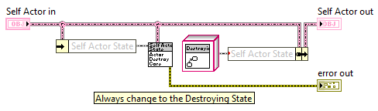
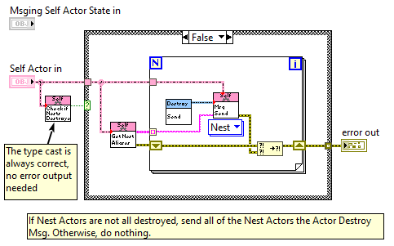
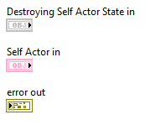

6.8.1. Dev Actor Override
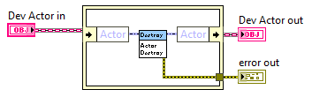

6.9. Actor Last Ack.vi
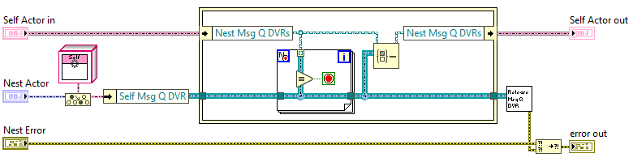
This directly tells the Actor that a Nest Actor has destroyed itself. Therefore, this is where the Msg Q DVR for that Nest Actor is released. This method should not be called anywhere in the Dev Actor. If the Dev Actor should be saved after it is destroyed, look at the section called Memento Pattern.

6.9.1. Dev Actor Override
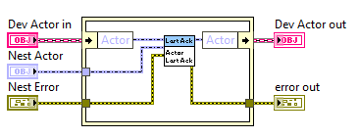

6.10. Polymorphic Msg Sends
This polymorphic method is used to send Msgs to Actors. Only the Msg Send method should be used by the developer. This shows easily, with the polymorphic drop down menu, the destination of the Msg (Call, Self, Nest).
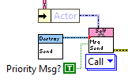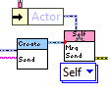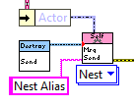
Msg Send is polymorphic (rather than with a dynamic dispatch input) so that the Dev Actor is forced to have an edit time determination of where the message should be sent.
The Actor (Self Actor) is unbundled from the Dev Actor, giving the method implicit access to the Msg Q DVRs. The developer must wire in the specific Msg object (with private data specified by the inputs to the Send method) and can optionally wire in if the Msg is a priority Msg (this is discouraged for most all messages, tend to use for emergencies). Exclusively for the Nest polymorphic option, the Alias for a Nest Actor is required to be wired in to determine which Nest Actor the Msg should be sent to. The developer has the option to use the Check if Nest Alias methd to determine if the Nest Actor is in the set. All of the inputs are for the Actor interface, but are internally cast to the Self Actor type in order to unbundle the respective Msg Q DVR. This is so that the developer does not need to always place down the “to more specific” function every time a message must be sent. The following picture shows the three polymorphic Msg Sends.
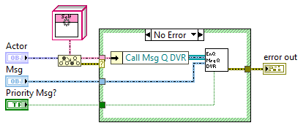
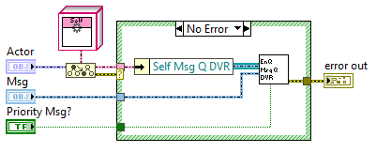
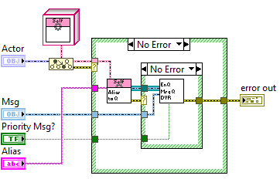

6.11. Create Top Level.vi
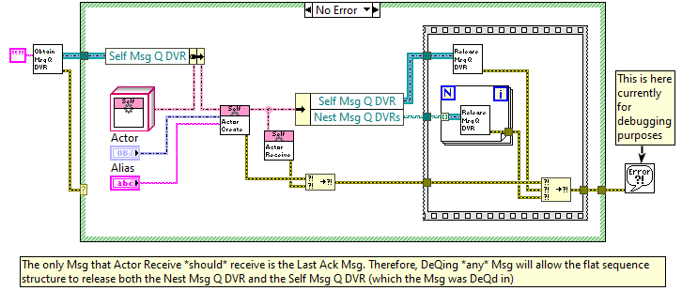
If a Self Actor has not been created, use the Create App.vi.

6.12. Check if Nests Destroyed.vi
Returns a boolean for Nest Actors Destroyed?

6.13. Check if Nest Alias.vi
Checks if the Alias is a part of the Nest Actors in the Dev Actor composed Self Actor.

6.14. Get Nest Aliases.vi
Returns the Nest Actor Aliases in the Dev Actor composed Self Actor.

7. Disclaimer
For the following sections, these are ideas that have only been written out and some implemented, but not fully revised. They’re still here in case it gives inspiration to what is to come.. please send suggestions (refer to the first page!) :)

8. Errors
There are two errors that can occur when using the LVCAM:
- LVCAM Errors (framework errors)
- Msg Errors

8.1. LVCAM Errors
Errors from LVCAM are only from Msg Q DVR methods.
These will happen exclusively at Msg Q DVR within the Self Actor.
all from the Msg Q DVR.lvclass methods (such as Msg EnQ or Obtain Msg Q DVR)
LVCAM Error actor that monitors if there is a LVCAM Error, then emergency stops the program.
Msg Q DVR.lvclass also has another DVR for the LVCAM Error that occurs. If an Error occurs, the program will immediately shut down everything since an unexpected error will result in behavior that cannot be handled. There could be some overriding of this Error that could occur, but this is a future matter.

8.1.1. Advanced
The "emergency stop" is categorized as a framework error. If a framework error occurs, then the orderly shutdown is bypassed and the destroy message is passed to the entire application. This happens when one single emergency message is enqueued in any actor,
This emergency message can only be enqueued by a toolkit such as the justACS Actor hierarchy inspector where there is a button to emergency stop the program. The only other way to emergency stop the program is by:
pressing a keyboard shortcut, default but user configurable
pressing *something* with the mouse, default but user configurable

there is a higher level DVR with access to all of the Msg Q DVRs. This makes EnQing a framework error to all of the Msg Q DVRs.

8.2. Msg Errors
These are errors that are created ONLY after a Msg has been executed. After these errors occur, they immediately go into Actor Teardown.vi for any intended clean up. If an error comes out of Actor Teardown.vi, the Actor Destroy Msg is sent to itself.

9. Benefits in PPL use
Because Msgs are inheritance based via an interface, this makes creating a PPL for a Msg VERY easy. Because every Msg has its own library, making these Msgs into a PPL is easy. For example, for an additional Time Delayed Send Msg (TDSM), this belongs in its own library and logic that governs its use is in the library and classes themselves.. completely contained in the PPL.

10. Benefits in Readable Connector Panes
ONLY show best practices.
For a given method in a class, ALWAYS have the class object at the top left and top right of the connector pane
if the class object is not used as an input and/or output, then leave these spaces blank.
Good practice:
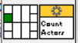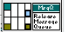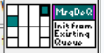
Bad practice:
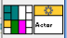
As a separate issue, as is preference, the LVCAM avoids the following connector pane since it doesn’t display object manipulation:

The preferred does show object manipulation. The object input at the top left and no object is output since the object is not being manipulated. Further, the output which is NOT at the top right shows a non input object output:
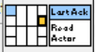
You’ll notice when navigating through the LVCAM, that all error wires are used strictly for errors.. more directly, they are NEVER used for serialization. That is why so many of the methods do not have an error input. This is because the methods should unconditionally be executed when called. If they are not, there will be an error case structure around the method itself in the block diagram that holds the method. If a method has an error input and an error output, this is not for serialization. It is because the error can be manipulated. This philosophy on error propagation follows object propagation on method connector panes where the top right of a method is dedicated for the object that comes out. The object output is not wired if the method does not manipulate the object put into the method. This aids in readability as outlined by DNatt:
Your LabVIEW Code Is a Work of Art... But I Can't Read It by Darren Nattinger. GDevCon N.A. 2024 39:21
AND
Your LabVIEW Code Is a Work of Art... But I Can't Read It by Darren Nattinger. GDevCon N.A. 2024 44:55

11. Benefits in Orderly Destruction
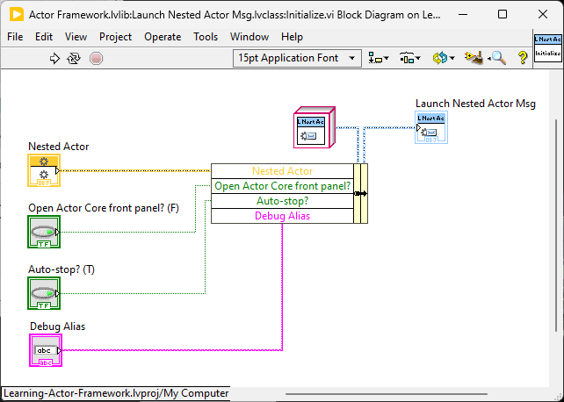Auto-stop? (T) (Depreciated)
What is an orderly destruction? Answer: The Self Actor can ONLY destroy itself when the Destroying Self State and Nest Msg Q DVRs = 0. The Self Actor can only Destroy itself once it has been ensured that all Nest Actors have destroyed themselves. The Self Actor knows that the Nest Actors have been destroyed only from DeQing the Actor Last Ack Msg and unbundling the Nest Actors Self Msg Q DVR.
Actor Destroy.vi can be sent to Call, Self, and Nest with the following case scenarios for doing so:
- Sent to Call: Call would just send the same Actor Destroy Msg back due to Orderly Destruction. This will put the Call into the Destroying Self State.
- Sent to Self
- Sent to Nest
Orderly Destruction states that receiving this Actor Last Ack Msg means that the Nest Actor Destroyed did NOT have any Nest Actors left.

11.1. Inspiration
- Re: Question: Actor framework, communication tree and stopping actors
- ECLA 2018 Efficient Actor Framework Development Allen C Smith
  - 17:36
  - Single vi that triggers Nest autodestroy (this is Actor Destroy.vi)
  - A method that destroys Nest Actors is not needed because Actor Destroy Msg does this immediately via the built in Orderly Destruction logic.

12. Benefits in Debugging
Open Actor Core front panel? (F) (Depreciated)
Open actor code front panel removed, and instead have an actor hierarchy inspector. This will show when and where an actor is created.
Alias:string in the Msg Q DVR.
note that the show actor core front panel should be deprecated because of the AF Debug library acting as hooks for messages and launching of actors, as seen clearly using the AF Hierarchy Inspector developed by justACS for the NI Actor Framework.
With the LabVIEW Composed Actor Model, a similar tool can be developed. Or.. idea.. a built in conditional to the framework itself which launches a similar "Actor Messaging Inspector". If this conditional is true, then a popup window displays the Actors and their respective Calls and Nests.

13. Benefits in Circular Dependency Elimination
Couple to abstractions (interfaces) rather than concretions.
Decoupling in Practice - How Good Software Engineering Can Save... by Allen Smith.GDevCon N.A. 2024 by Allen C. Smith
Circular dependency issues occur because of classes.. within libraries
Coupling to Interfaces (where interface within its own library) gets rid of this entirely
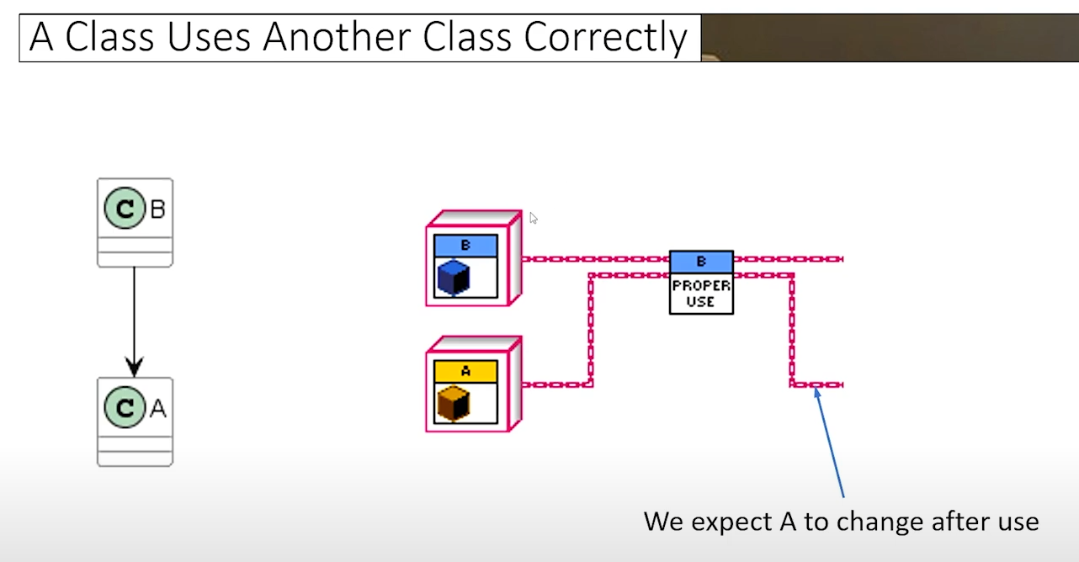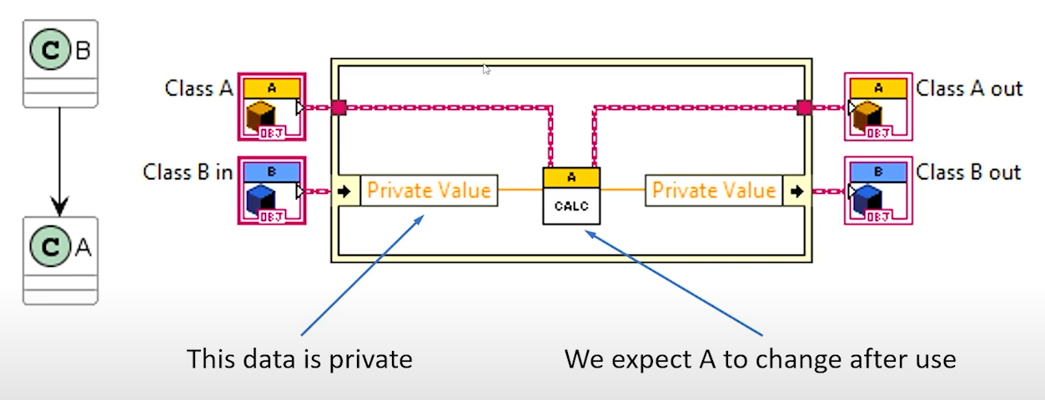
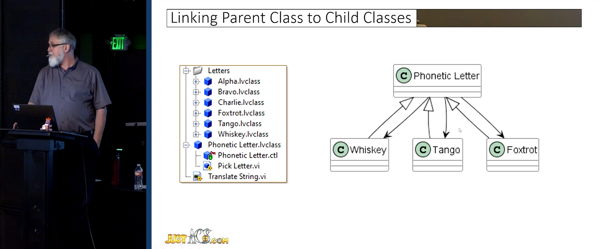

Dmitry end of video on timing build load times coupled to abstractions, not concretions.
Why, When and How to Protect Your Code from the Framework - Dmitry Sagatelyan -GDevCon#5 27:44

14. Benefits in Composition
Benefits of using a composed system? Answer: Object transfer i.e. State Pattern and User Interfaces.
What is my goal: state patterns interchange the panels. just like in the justACS presentation

14.1. Dev Actor Helpers
not allowing the user to override the message core discourages the user from creating a helper loop in their code and should put emphasis on using an Actor Helper instead.
The Actor Helper Replaces the “Helper Loop in AF”.
All Actor Helpers are extended features.
Disclaimer: The Actor Helper strictly sends and receives messages. Although not enforced by the framework, one should not create any Nest actors. Instead, create the Nest actors in the Self Actor.
Re: Is sending message to a nested actor from helper loop of root bad code?
eliminate helper loops and instead run these under the category “Actor Helpers”. This “Actor Helper” is the Front Panel Actor.
Any helper Loop (while loop with event structure) should be replaced with an actor with messages. This is simple to inherit from the interface because the helper loop otherwise only EnQs messages and potentially has private data in its own shift register independent of the actor.
note on replacing the helper loop: this helps developers to use data strictly on the class wire, not branching to helper loops.
For the helper loop, only messages can be inserted to the Call Msg Q DVR and Self Q. Messages cannot be directly Qd to the Nest Msg Q DVRs. This is because the Nest Msg Q DVRs are dynamic and may not exist / change their refnum over the duration of the actor lifetime. If a Nest Msg is required, use the dedicated Helper Nest Msg.lvclass.
The External Msg Q DVRs are dynamic. The Self Msg Q DVR is static.
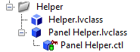
Idea for two templates: actor panel
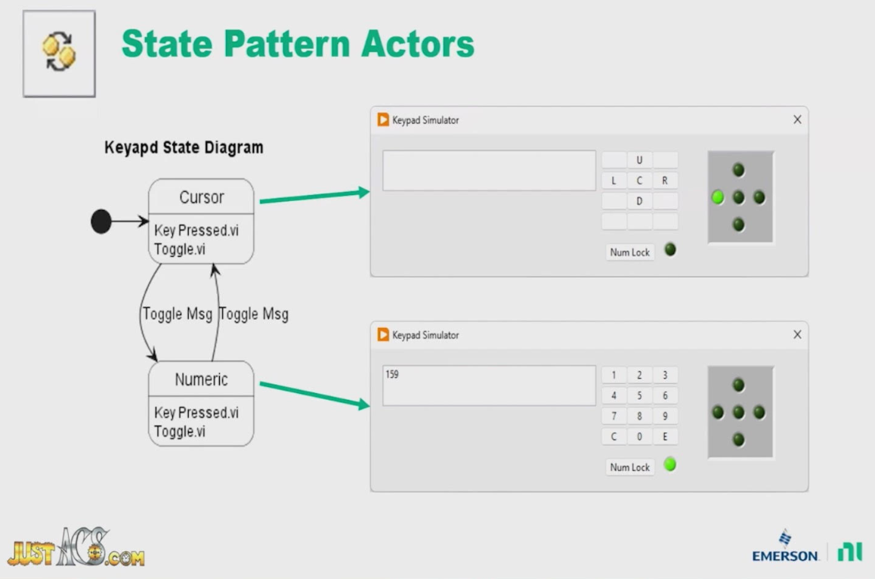
State Pattern mixed with interchanging panels

State Pattern: pass in object

Look into panel actor after just ACS has published.
Also, check the MGI Panel Actor.

14.1.1. Panel Helper
Example for Event Async Processes
DAQ Register for events as a “Async Helper” 1. Cannot receive messages
2. Only send messages

Panel Create Msg
Input of Actor interface
Panel is the Traditional UI.
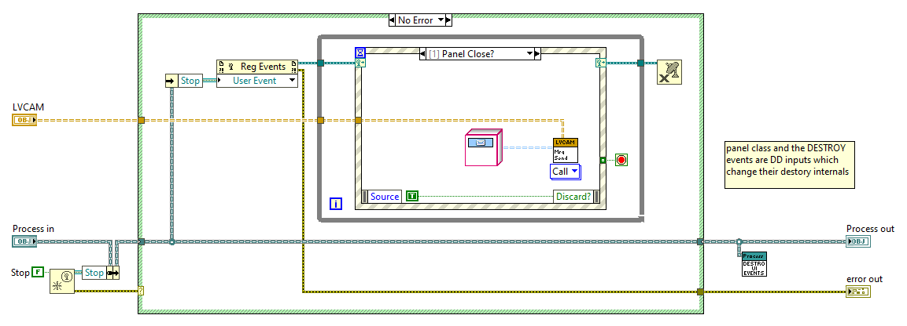
This is just a template.
The template auto populates the event structureThis is because inheritance strictly has the user inherit from this and NOT anything else.. Therefore, if there comes along another inheritable package your actor must inherit from.. this could not work since a child can ONLY have one parent.
Therefore, composing in the Panel Actor yields well to allowing multiple Panels to be used at runtime
—this extension of state pattern where you compose in the Panel Actor where its children implementations for the actual actors to use their front panels (numeric and keypad). These can be swapped at run time for your panel of interest.
Toolkit that allows quick scripting creating the necessary decorator (wrapper) methods for use of panel actor. (moZart?)
“Context” composes in “Panel Actor” and inherited Actor used for changing state.

The Panel Helper was not put into the main LVCAM (though it will almost always be used) because it inadvertently shows the developers how to make their own messages and packages to go composed in along with the Actor. This is a dedicated helper loop here for updating controls and indicators.
It is ABSOLUTELY DISCOURAGED to use the Nest Msg Send in the helper loop, this is because the Actors data that is input into the helper loop is not guaranteed to have the correctly updated Nest Msg Q DVR.
As all Actor Helpers are extended features of the LVCAM, the Panel Actor Helper. This has features that closely resemble that of the UI for Actors Indicators. Note that this requires scripting.
Every class that has a composed Actor.lvclass (Interface) and uses UIs should compose in the Panel Actor Helper Interface.
Interchange the front panel without requiring one to change the Actor Loop (loop can keep running), just that the panel is changed. So, send a message to say “Show Panel?” and when the message is DeQd, the front panel displays. The developer does not want to see the front panel, until it has been created.

14.2. Memento Pattern
By design, LVCAM has no way of saving the Nest Actor, if one wants to create that actor again with the object saved (potentially different private data for the object)
This is an example of a memento pattern i.e. saving an object.
Saving the Nest Actor is done after the Actor Destroy.vi (case structure that when the Destroyed Self? = true, then send the memento message to the Call actor with the actor itself)
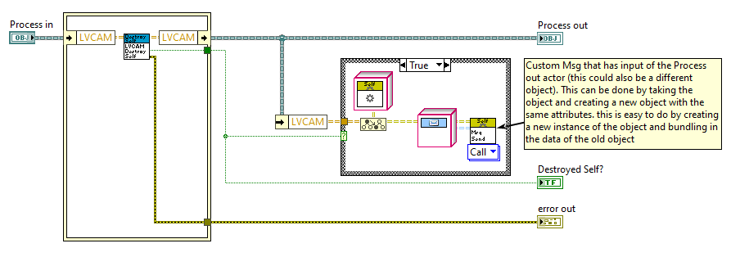
THIS SHOULD ACTUALLY BE IN THE Teardown.VI!!!!!!!!!!!!!!!!!!!!!!!!

14.3. State Pattern
To handle the case of protected DD methods not being able to be used in State concrete class.. solve by making a wrapper method (SD) that wraps the protected DD method. Make this SD community and put this into the state concrete class
Possibilities for Methods in State
Protected, not for AF messages (only used within class (since no child classes)
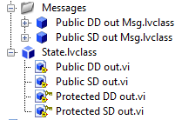

Advantage: No need to rewrite parent attributes, object in private data.
When writing context to class inherits in State Transition, the parent AF:Actor.lvclass attributes get carried along as well with the concrete class? Check this in small example
Think State Pattern, needing to rewrite parent attributes.. ugh! Too much work!
A Class Act - Allen C Smith(JustACS) - GDevCon#4 by Allen C. Smith
my idea: composition gets rid of needing to also copy over the parent classes attributes
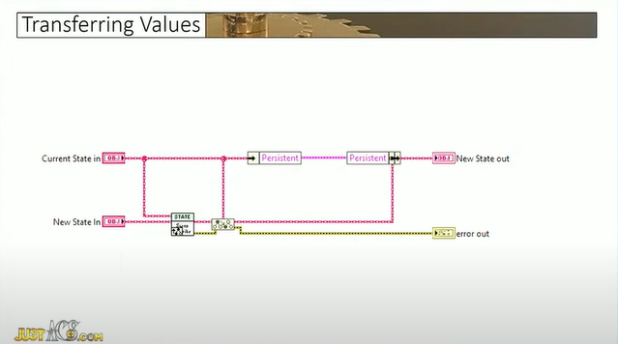

14.3.1. State Pattern (DD out)
Actor code has DD in AND DD out. This enforces the same object to be passed throughout the entirety of the class.
If you want to swap a class.. no problem, just unbundle and bundle the data you are changing.

14.3.2. Fill in name
Interface has two subtypes: Context and State. Therefore, Enter and Exit must be overridden in Context. Within Enter and Exit, just treating them as Wrapper methods! Here, wrapping Enter and Exit that read the State (Interface). It must be noted: in Actor Core, you MUST write the concrete implementation to the state (Interface).
Best practice:
NOT to call methods before a state transition because the Context wire must be updated. Call methods only AFTER the Transition State.vi, not before. This is because the updated Context state has not been established on the wire, it is only the default implementation.

14.3.3. SD outputs
Must be DD input if the method corresponds with a message. If this is the case, then the output could also be DD.
If a state transition will occur in any of the concrete states, then the output MUST be SD. otherwise, to declare to the compiler that the concrete state in will be the same as the concrete state out: make the output DD.

14.3.4. State pattern messages not handled
Re: DVR or data copy? How to deal with large data in AOP projects
Idea: if a message comes in and the state is in an idle mode, the message that is DeQd (that isn't executed is put into an array of messages so that when the state changes, it (in the entry method) enQ all the messages again for the running state

14.3.5. States.ctl enum replaced with as State Pattern?

14.3.6. Godspeed notes
state pattern..
refactor to follow the rule couple to abstractions rather than to concretions.

The point is, for the state concrete classes: do not have a dependency to the context class.. rather, just some data that the class uses i.e. unbundle the context private data and have these be inputs to the concrete classes.

State Pattern Test:
Display the data as graph or numeric
(Different front panels)

15. Observer Pattern (Pub Sub Pattern)
The Actor Model is really a constrained Observer (PubSub) Pattern. Where an actor sends a message to certain subscribers. It just so happens that most messages have only one subscriber for that message.

observer pattern: relation to messages? New pattern? SOLID friendly?
Composition is related to composition?
https://forums.ni.com/t5/Actor-Framework-Discussions/Pub-Sub-in-AF/td-p/4267843/page/2

This pattern enables safe cross-tree Msging.
This is an extension to the tree-like hierarchy of messages.
“Cross Tree?” boolean input on Create App.vi (Actor Create.vi too). Gives the created Nest Actor the ability to:
- create Subscriber Nest Actors and
- create Publisher Nest Actors
which can be shared to all actors that also have this “Cross Tree?” boolean marked true.
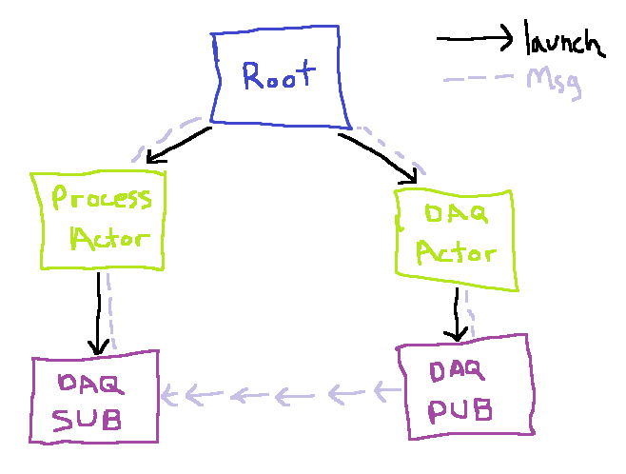
using the Publisher Subscriber (PubSub) Pattern as an extension promotes safe messaging across the tree-like hierarchy of messages.
When creating the application, a DVR holds the Msg Q DVRs of all Publishers (Pubs) in the system.
How this works is that if a message would like to be transported to another actor, but requires moving the message through at least one other actor along the way, the PubSub Pattern is encouraged to use. At the start of the application, a DVR singleton object is created which holds the reference to the current Pubs in the application (This is dynamic). Created are Root, Process, and DAQ. DAQ wants to send a Msg to Process, but must first send to Root, which Root sends to Process. Instead, DAQ creates a Nest Actor called DAQ Pub. When DAQ Pub is created, the DAQ Pub name is added to Pubs which holds the Actors in the system that are publishers. Every Actor in the application can access. The Pubs DAQ Pub can only receive Msgs from DAQ and forward the same message to the Sub Actors. But what if there aren’t any Sub Actors? Answer: No Msgs are sent since no Subs have been created!
Every Actor in the application should (must?) have a unique Alias:string.
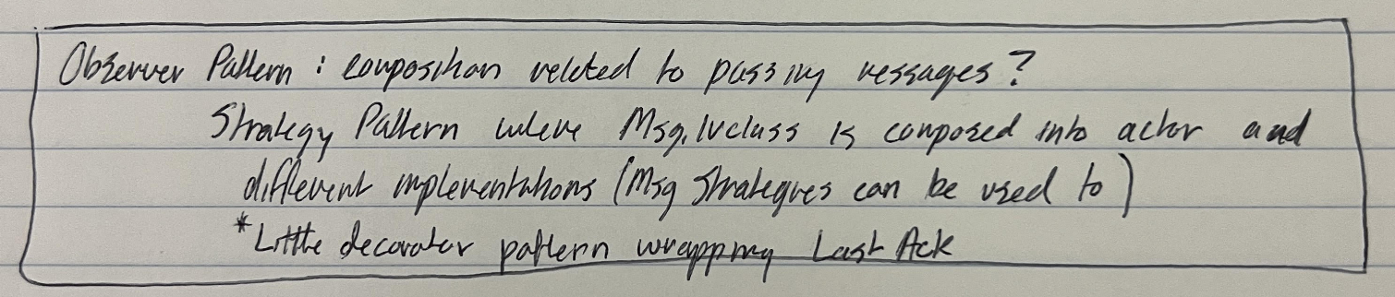

16. Singleton Pattern
3:20
https://youtu.be/tAuRQs_d9F8?feature=shared

Singleton: Application State
App.lvlib:App.lvclass:Load App
Creates a singleton for the root actor so that this App.lvclass cannot have another instance.

17. Factory Pattern

17.1. Loading Actors (Object Serialization PNR)
Strategy Pattern to load classes (actors) VIPM
Class Loader Strategy:
Constant strategy: simply typing a path into a path constant
Disk Strategy: Disk Path (relative or absolute)
JSON Strategy: load from JSON file, with necessary parameters

note from stephen:
Stephen serializes objects. tried to serialize with interfaces.. (which presentation?)*
my idea: No abstract class needed. Use an interface with protected methods used in concrete classes. Compose in

create configuration class
https://forums.ni.com/t5/Actor-Framework-Discussions/Load-App-Pre-Launch-Actor-Activities/m-p/3404933#M1927

plugins: parent Actor Framework.lvlib:Actor.lvclass
https://forums.ni.com/t5/Actor-Framework-Discussions/Plugins-AF/m-p/3399030#M1433

18. Process and SubProcess (Example)
Let’s examine what we need our classes to do
Child:
- Inherits interfaces to extend or override methods specific to
  - Actor
  - Msgs
- private methods / .ctls specific to other Child methods

18.1. Creating Actors
Load App configuration class composed in.
Configure should not be public, but rather handled in Load App where inside the factory pattern is used with JSON to serialize the object
When creating a new actor with Actor Create.vi, using the factory method for proper decoupling can lend nicely to having a map of the Msg Q DVR and also the path for the actor being created.

18.2. Actors composed within Actors
It is a personal preference that the developer should favor composition over inheritance when creating actors. In particular, instead of Class 2 which would otherwise inherit capability from Class 1 (that contains Actor.lvclass), have the Class 1 be composed into Class 2. This helps so well when moving object data around at one central object instead of moving object data in both a parent and child. This approach is solved as presented as a problem here:
The State of the Art for Actor Framework 33:16
No need since this model does not have the ability for inheritance, by design. Composition favored.

19. Accessor methods
Look into making the methods that access data: accessor methods and use them as property nodes. NEVER need to edit the icon since property nodes will be used instead.
DNatt best practice: Have class property vis to just ONLY bundle and unbundle things!
Should avoid putting extra functionality in the accessor method. If you do put in more functionality, then put a plus next to the accessor method name.
- Your LabVIEW Code Is a Work of Art... But I Can't Read It by Darren Nattinger. GDevCon N.A. 2024 20:14
- LUDICROUS ways to Fix Broken LabVIEW Code with Darren Nattinger | GDevConNA 2022 29:16
note this idea exchange also with commentary in the below timestamp by SLM
OOP Interfaces, automate data accessor code
NI Connect 2022 LabVIEW Interfaces Things Better Left Unstated 41:49

19.1. Ideas
TDSM another Actor Helper, with queues. Where there is only the timer and it is in an event with only the timeout which continually sends the “Helper Msg.lvclass”

Helper:UI:Cluster (has references) in the class private data holds the UI Helper stuff.
TDSM
Helper:

Self

Self Msg in case (start immediately), then event structure while loop that times out after every case.

Private data for TDSM do not change (changed data occurs in actors private data instead).

How does LV have near perfect SW timing? This is for the custom message called TDSM.

UI Events in ONE method
Instead of SubVI that closes references (make general?) or use Q to close references!!!

go through document and replace the pictures of process with Dev Actor

State pattern is really.. with Enter and Exit.. just a template method I.e. a decorator pattern!

Update headers in Documentation
Replace names that are replaced in document curl+f

*check out the panel actor settings for creating a panel (what are the window properties?

Also, this could also be an async process? Because this is an asynchronous window?

Why is the event loop an sync process?

have the self actor be the input for the Open UI, that way this can be a async process with this input

have a breakpoint for all of the important methods both in the Dev Actor and the Self Actor, that way when running the program, the developer can debug the path that the messages are moving. placing a breakpoint means that the developer can step over and see which method is being executed.

create a UML for the messages (inheritance tree)

Close Panel Msg
Show Panel Msg
Hide Panel Msg

These are messages for all panels
It just so happens that panels that are closed can ALSO destroy

Dev Actor can send ANY message. Whether the message can be dequeued is up to the actor that receives the message.

Subpanel and window inherit from panel
Panel action interface composed into both and has concrete show panel and close panel classes

Obtain and release for naming with queues instead of create and destroy

MSG.vi: do you need the tsc before and after method? It’s already DD on both sides

Msg Send has the distinction of Call, Self, and Nest. These are Msgs that are sent to the relative Actors via the under the hood Msg Q DVR.

Rename Msg with Msg Strategy

State pattern
Stay away from passing objects as parameters.. unbundle the necessary private data.

States
Msging State
Destroying State
Destroyed State

This eliminates the Boolean for the Msg Class only allowing the

The Dev Actor is the Actor that is being developed.
The Self Actor is what the Dev Actor is decorating
Actor is the interface

State Enter.vi
State Exit.vi
State Change.vi
State xxxxx.vi
State yyyyy.vi
State zzzzz.vi

tips:
- no need to initialize a shift register when the method is shared reentrant
- Msgs can have ONLY a DD input, without the DD output! That’s valid!

1. For tightly coupled actors, I'm curious how others tackle this problem: If there's an asynchronous process occurring which strictly helps an actor, normally I'd spin up another actor that does the process and reports back some information to the actor that created it. Question: Should this helper process really be another actor? Or should this be some new variant called say an Actor Helper which doesn't receive messages, rather only having the ability to send messages to the actor that created it and closes when that same actor tells it to close (something like a generated event or single element queue to close the Actor Helper). I have worked on this a little bit and I do have example code, albeit with an actor model that I have been developing.. the async process deals with panels and strictly follows the rules I put above. Is there a better way to handle this? Do others just spin up another actor and call it good?
2.This is kind of out there, but as a thought experiment: If say there exist ONLY interface messages, would there be any benefit to have a different kind of message that exclusively is sent to itself? Or priority thread that runs in parallel with the normal actors thread, but only dequeues these special self messages? Kind of rambling, but instead of inheriting from the Message.lvclass, there's some deeper hierarchy that is the Self Message.lvclass? This better differentiates what kind of message is being received?
3. Is there a toolkit available, similar to the right click menu that creates an actor message, that creates a library, interface, and message class for a right clicked actor method? So instead of the message class being created, a library, interface, and message class are created?

